SET 12 – Website Traffic Analysis
Aim
To analyze website traffic data using a line chart, bar chart, table, and an interactive Tableau dashboard.
Dataset: Website Traffic
Date | Page Views | Click-through Rate
2023-01-01 | 1500 | 2.3%
2023-01-02 | 1600 | 2.7%
2023-01-03 | 1400 | 2.0%

Program 1: Line Chart for Daily Page Views
Create a line chart to visualize the trend in daily page views over time. Label the axes and title the chart.
# Create website traffic data
date <- as.Date(c("2023-01-01", "2023-01-02", "2023-01-03"))
page_views <- c(1500, 1600, 1400)

# Create line chart
plot(date, page_views,
type = "o",
main = "Daily Page Views Trend",
xlab = "Date",
ylab = "Page Views",
col = "blue")

# Add values
text(date, page_views,
labels = page_views,
pos = 3)

Output:
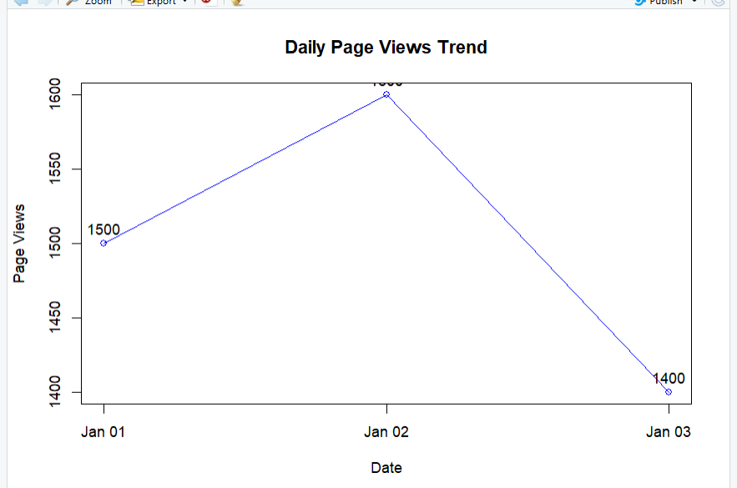
Observation:
The line chart shows the daily page views and helps identify the increase or decrease in website traffic over time.

Program 2: Bar Chart for Top N Click-through Rates
# Create website traffic data
date <- c("2023-01-01", "2023-01-02", "2023-01-03")
ctr <- c(2.3, 2.7, 2.0)

# Sort data in decreasing order
order_data <- order(ctr, decreasing = TRUE)

date <- date[order_data]
ctr <- ctr[order_data]

# Create bar chart
barplot(ctr,
names.arg = date,
main = "Top Days by Click-through Rate",
xlab = "Date",
ylab = "Click-through Rate (%)",
col = "skyblue",
border = "black")

# Add values
text(seq_along(ctr), ctr,
labels = paste0(ctr, "%"),
pos = 3)
Output:
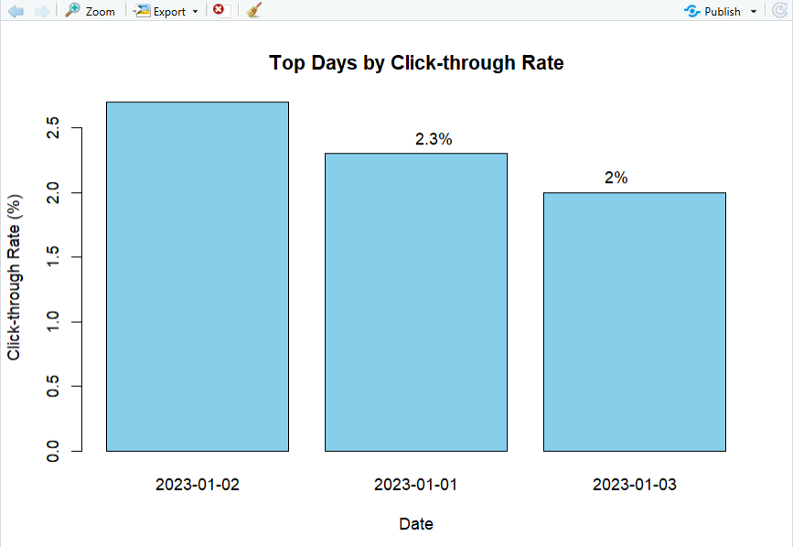
Observation:
The bar chart compares the click-through rates for different days and shows the days with higher click-through rates clearly.

Program 4: Tableau Dashboard
Develop a Tableau dashboard combining the line chart, bar chart, and the table for interactive
exploration of website traffic data.
Procedure:
- Create an Excel file containing Date, Page Views, and Click-through Rate.
- Import the Excel file into Tableau.
- Create a line chart using Date and Page Views.
- Create a bar chart using Date and Click-through Rate.
- Create a table displaying Date, Page Views, and Click-through Rate.
- Create a new Dashboard in Tableau.
- Add the line chart, bar chart, and table to the dashboard.
- Arrange the visualizations neatly.
- Add filters or dashboard actions for interactive exploration.
- Give the dashboard the title Website Traffic Analysis Dashboard.
- Save the Tableau workbook.
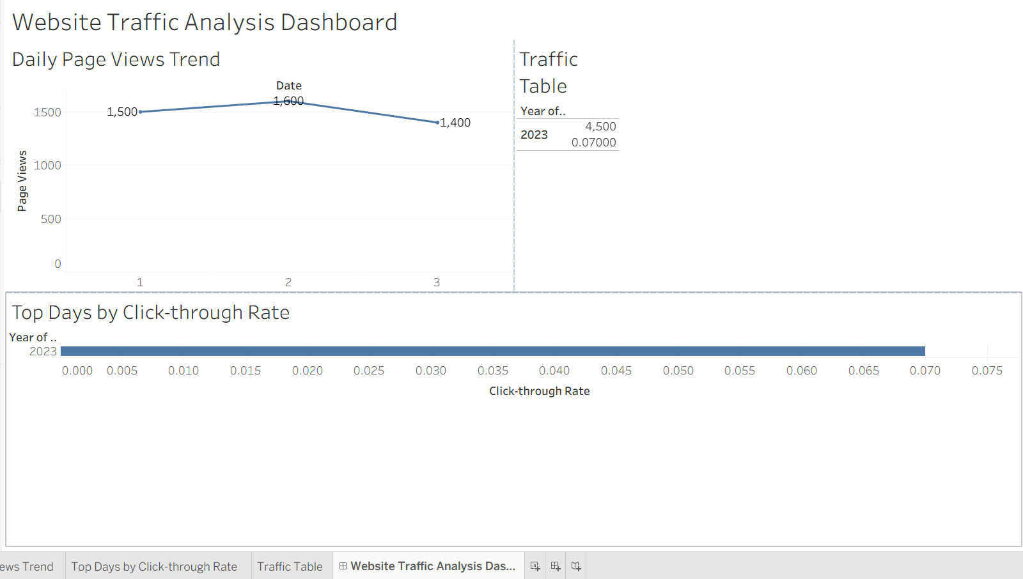
Observation:
The dashboard combines different visualizations to provide a clear view of website traffic and allows the data to be explored interactively.

Program 3: Website Traffic Table
Build a table to show the website traffic data for each day. Label the table elements.
# Create website traffic data
traffic_data <- data.frame(
Date = c("2023-01-01", "2023-01-02", "2023-01-03"),
Page_Views = c(1500, 1600, 1400),
Click_Through_Rate = c("2.3%", "2.7%", "2.0%")
)

# Display the table
print(traffic_data)
Output:
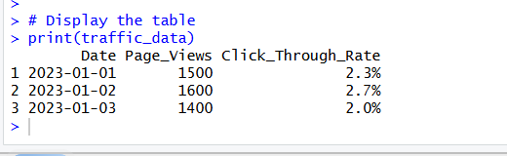
Observation:
The table clearly displays the daily website traffic information along with page views and click-through rates.

Set 12 Procedure
- Create the website traffic dataset containing Date, Page Views, and Click-through Rate.
- Use R to create a line chart for daily page views.
- Create a bar chart to compare click-through rates.
- Create a table to display the website traffic data.
- Import the dataset into Tableau.
- Create the required visualizations in Tableau.
- Combine the visualizations into an interactive dashboard.
- Apply suitable labels, titles, and filters.
- Save the completed dashboard.
Set 12 Result
Website traffic data was successfully visualized using a line chart, bar chart, and table. A Tableau dashboard was also created to provide an interactive view of website traffic and click-through rates.

